

**HP Simplify Program**

**Business Process Document**

|  |  |
| --- | --- |
| *Document Name* | E2E-506b Back-to-Back Indirect drop ship (HOI) from International Vendor |
| *Document Version* | 1.0 |
| *Document Owner* | Creator: Manuel Rojas Vasquez |
| *Unit/Team* | Customer support supply chain |
| *Last updated* |  |

# Revision History

|  |  |  |  |  |  |
| --- | --- | --- | --- | --- | --- |
| Date | Update Description | Sections Updated | Editor | Version | Approvers |
| 6/14/2021 | Initial version |  |  | 1 |  |
|  |  |  |  |  |  |

Table of Content

1 Revision History 2

2 Objective 4

3 Scope of This Document 4

4 Terms and Definitions 4

5 Business Process Description 5

5.1 IC Purchase Requisition Creation 5

5.2 PO Info confirmation 12

5.3 SO modifications 15

5.4 Trade PR creation 22

5.5 Trade PO modification 26

5.6 Inbound Delivery Creation (ML steps) 30

5.7 Post Goods Receipt 53

6 Process Flow Chart 56

7 Addendum 57

# Objective

To document the list of processes the planner/buyer will face for the End-to-End release for the process labeled “E2E-506b Back-to-Back Indirect drop ship (HOI) from International Vendor” for S/4 Hana as part of the Simplify S/4 Hana project 2021.

# Scope of This Document

N/A

# Terms and Definitions

|  |  |
| --- | --- |
| Acronym | Description |
| PR | Purchase Requisition |
| PO | Purchase Order |
| GR | Goods Receipt |
| 3PL | 3rd Party Logistics |
| S/4 | S/4 Hana (SAP system) |
| CS | Customer Support |
| SC | Supply Chain |
| EDI | Electronic Data Interchange |
| FO | Framework Order |
| ME21N | It´s a transaction name that takes place on SAP to create POs in S/4 |
| ME23N | It´s a transaction name on SAP to display POs in S/4 |
| ME51N | It´s a transaction name on SAP to create PRs in S/4 |
| ME59N | It´s a transaction name on SAP to automatically create POs from PRs in S/4 |
| ME52N | It´s a transaction name on SAP to change PRs in S/4 |
| VA03 | It´s a transaction name on SAP to display sales documents in S/4 |
| VL31M | It´s a transaction name on SAP to create inbound deliveries in S/4 |
| VL10A | It´s a transaction name on SAP to display sales orders in S/4 |

# Business Process Description

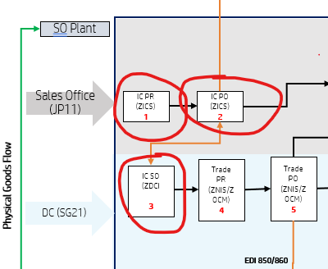

## IC Purchase Requisition Creation

### Enter to S/4 Customer Support Supply Chain production environment using the following link:

[https://sapfiori-s4.corp.hpicloud.net/sap/bc/gui/sap/its/webgui#](https://sapfiori-s4.corp.hpicloud.net/sap/bc/gui/sap/its/webgui)

### On your S/4 CS SC home page, select **Create Purchase Requisition (ME51N)**.

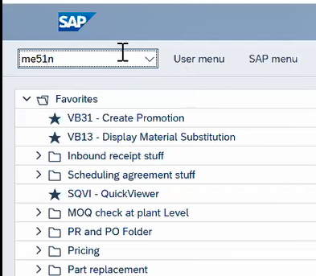

### Select **ZICS** which is for ***Inter Comp CS PR*** from the dropdown menu

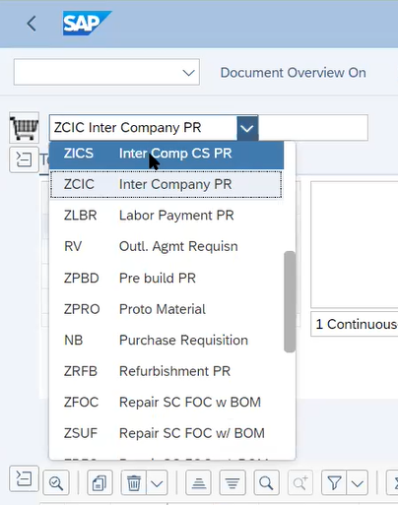

### On the next screen, add the following data and press the **Enter** button on your keyboard:

* Material Number
* Quantity
* Plant: must be **11CR**
* Storage Location: must be **FG01**

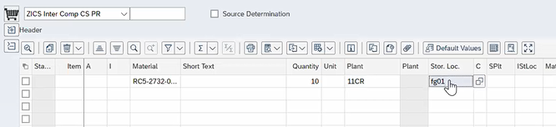

### Go to **Source of Supply** and select **Assign Source of Supply**.

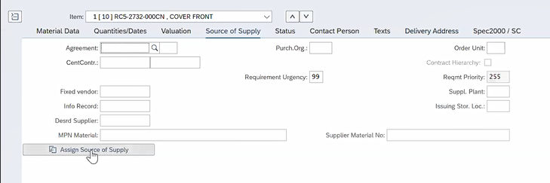

### On this tab you must select **HPSUS21** (DC) as your vendor,and then click on the **Assigned Source** button.

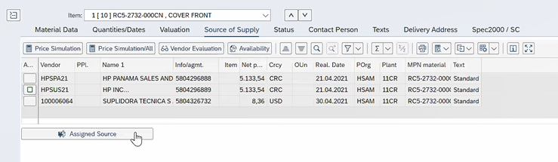

After the vendor has been selected all the info from the vendor will appear automatically on the **Header** level.

### Go to the **Validation** tab and verify that the **Valuation Price** is filled, basically ensure that it´s not blank.

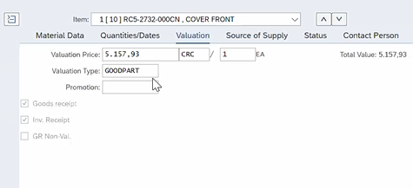

### Then click on the **Check** button.

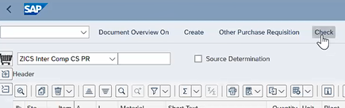

Depending on your configuration display the **check** button may appear with a symbol instead, like the one below:

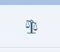

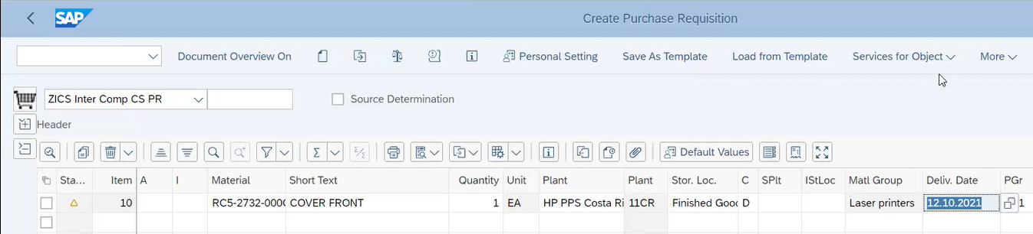

### If everything is fine and complete on the PR you will get the following notification pop-up window, so you just need to click on **OK**.

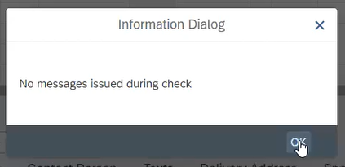

### Finally, save all the changes on the **Purchase Requisition** by clicking on the **Save** button at the bottom of the page.

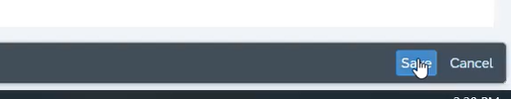

### Select and Copy the **Purchase Requisition Number** that is shown on the pop-up message at the bottom of the page.

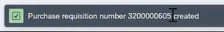

### You will have these two options to obtain the PO:

1. Wait 15 min. for the PO to be automatically created by S/4

or

1. Manually create the PO based on the PR number (view Addendum)

**End of PR creation**

## PO Info confirmation

### To find your PO number go to T-code **ME53N**, then click the **Other Purchase Requisition** button

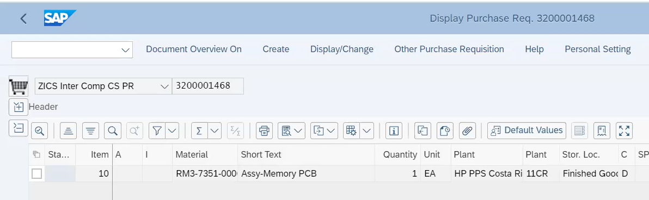

### Enter your new requisition number on the pup-up window and press the **Enter** button on your keyboard.

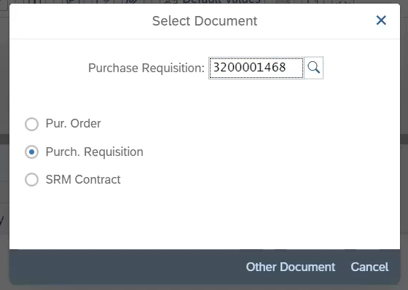

**Note:**  On this pop-up you window you can either look for your Purchase Requisitions or your Purchase Orders depending on what you are looking for.

### To find your PO number click on the **Status** tab. You can double click on the PO number to enter directly in it. On this sample below your PO number would be 3200001875

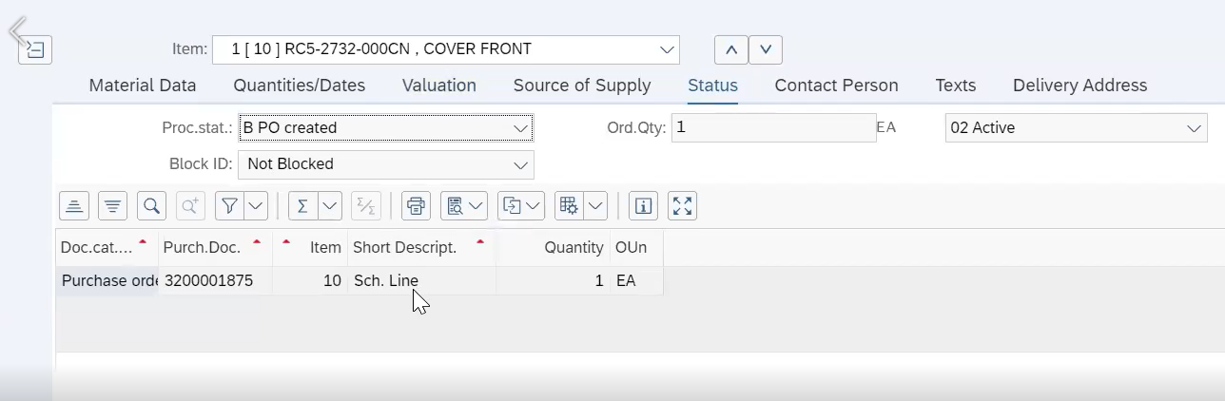

### Once you are on the PO, go to the **Confirmations** tab, you will see that a Sales Order number has been automatically created.

It appears on the column that says **Reference** or also on the **Order Ack** field, these two numbers are basically the same.

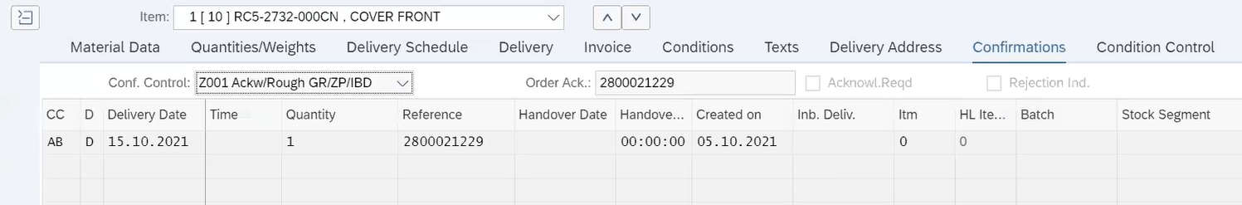

Note: Sometimes the **Order Ack** might take a little longer to appear, if this happens you can refresh the page and it will appear.

### You can verify the Messages tab located on top of the screen

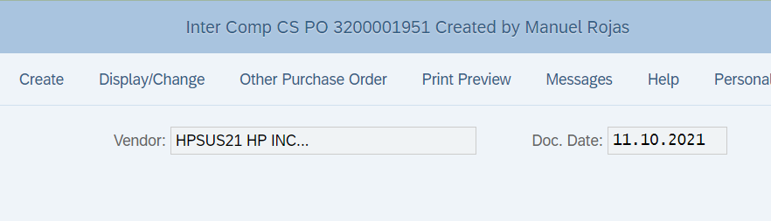

### And verify that the Outputs types **ZISO** & **ZSCT** appear.

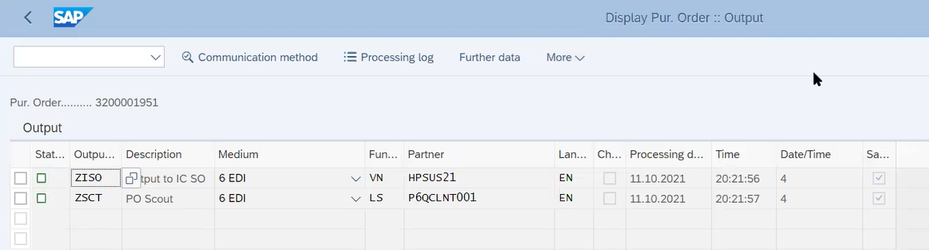

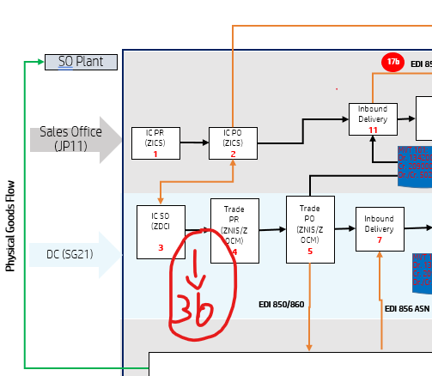

## SO modifications

You will need to change the **Item category** on the Sales Order so the **ZOCM PR** gets created. The item category must be changed from **ZTIC** to **ZC3P** if DC planner decides to buy from regular **new buy supplier**.

The storage location must be changed from FG01 to VG01 in the Sales Order.

A new Doc must be done for the following:

* from **ZTIC** to **ZS3P** if DC planner decides to buy from **broker supplier (WE´LL DO ANOTHER DOC. FOR THIS)**
* For this other document also the storage location must be changed from FG01 to VG01

This action should be done by the DC planner; but depending on the business needs this may change.

### On the T-code bar at the top of the window, type the t-code **VA03** and press **enter**, this will open a new window.

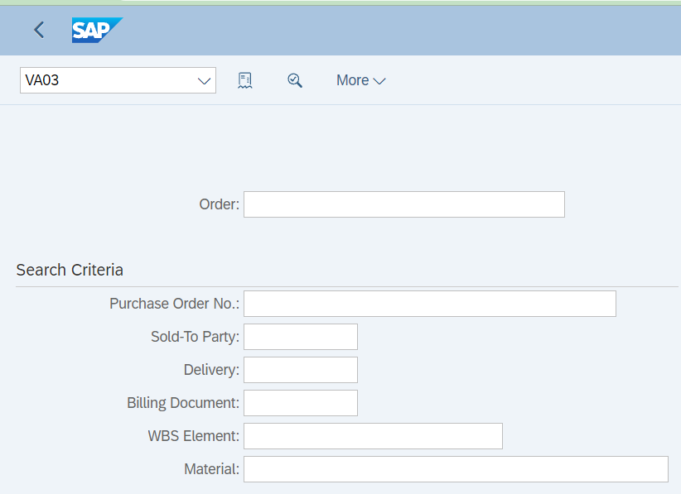

On this screen you will have two options to retrieve the info required:

Option 1: **Sales Order** (Order Ack) number and click on **Search**

Option 2: **PO Number** and click on **Search**

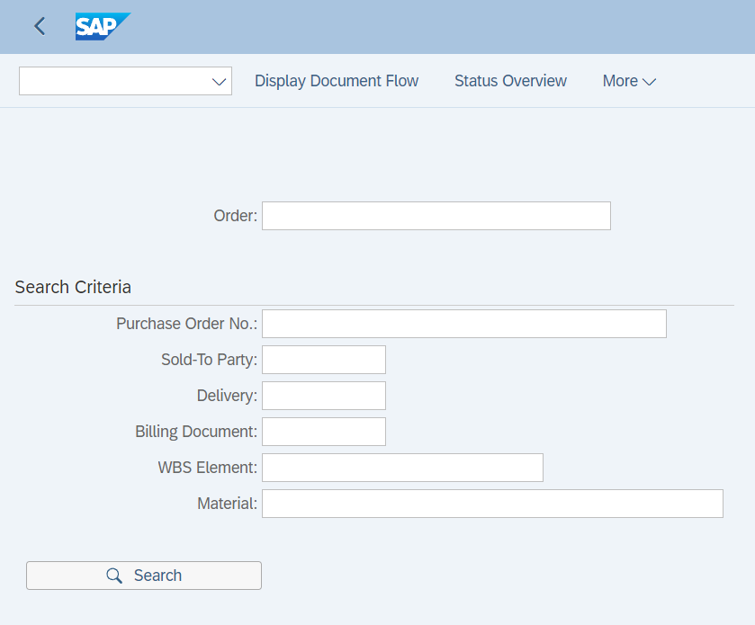

### If PO number is selected (option 2) it will ask you to click the **check mark**, this will open the **Sales Order** also.

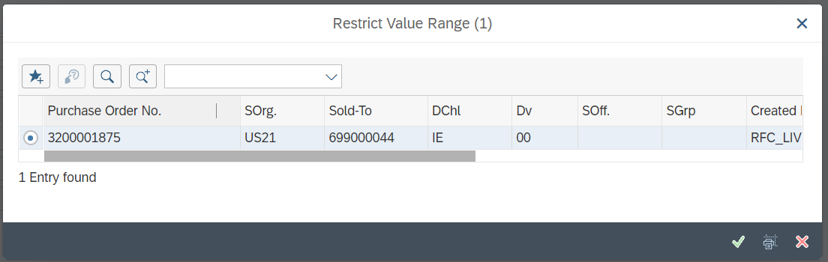

It is recommended to verify if the Incompletion Log is complete on the Sales Order, to do this you have to click on the **More** button, then choose **Edit** from the dropdown menu, then look for **Incompletion** **Log** and click on it.

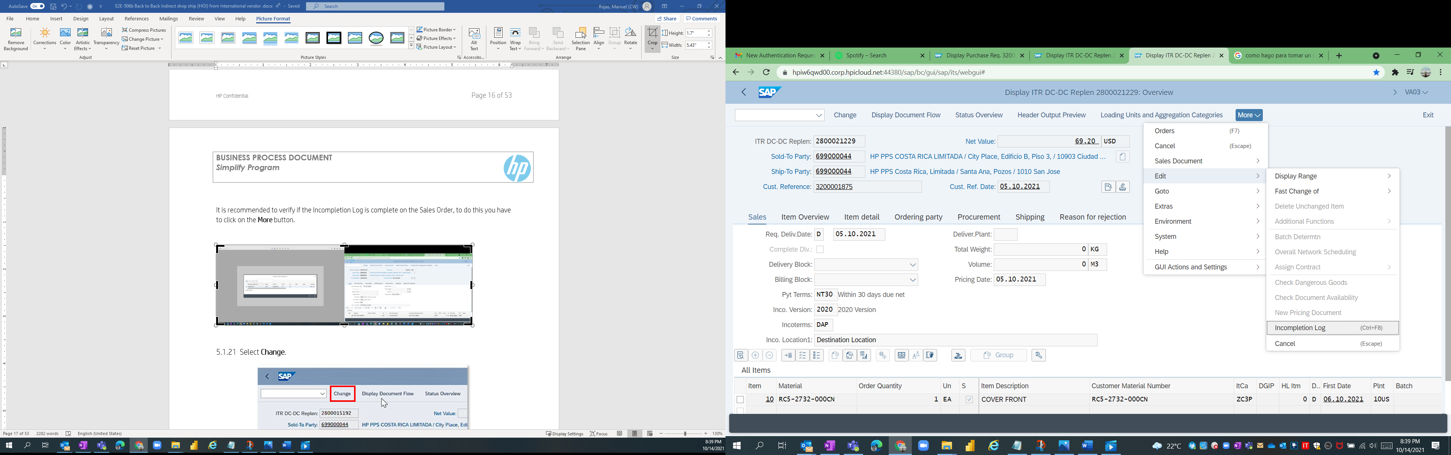

This is the message you will get if the Log is complete.

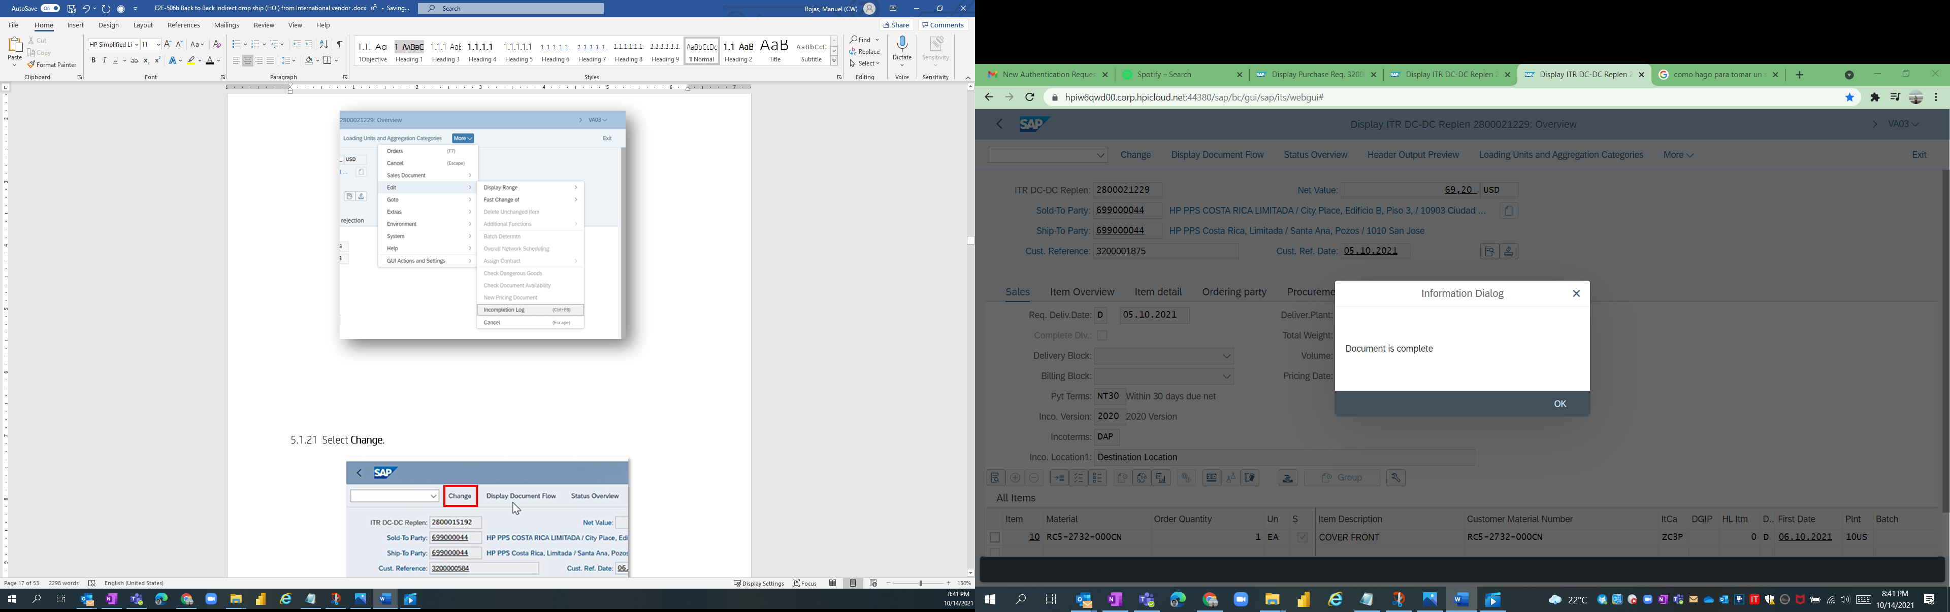

### Click on the **Change** button to go on edit mode.

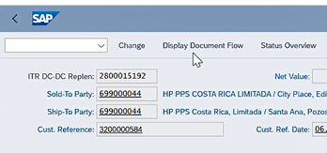

### Open the **Item Category** menu.

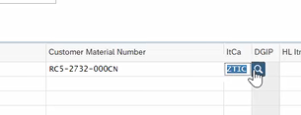

### Change the **Item Category** toreflect:

If no inventory available even in cross regional DCs, a change by the DC planner/OM analyst needs to be done in the Item category of the Sales Order so the inventory can be fulfilled.

There are 2 options:

Option 1: Change from ZTIC to **ZC3P** for triggering PR/PO **ZOCM** (External Vendor – Regular NB source where-in HP have contracts with external vendor)

Option 2: Change from ZTIC to **ZS3P** for triggering PR/PO **ZNIS** (Broker Source)

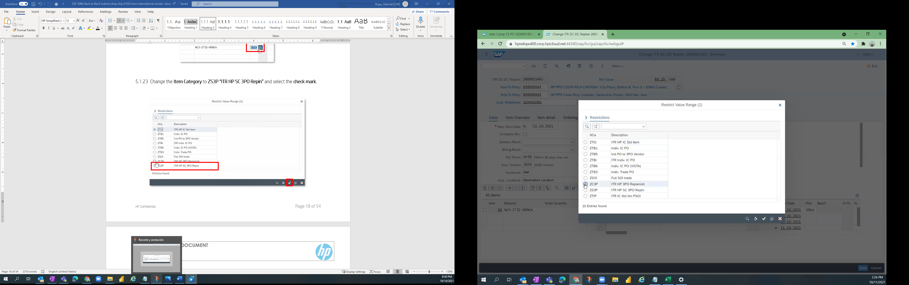

To get access to these tabs you need to double click on any of the figures of the line items

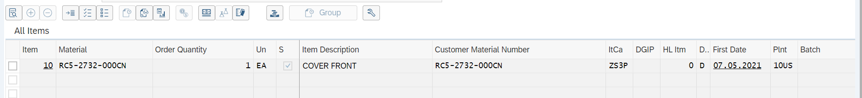

On the same Sales Order, go to the **Shipping** tab and confirm the information for

* **Plant:** 10US (it could also be 13PA)
* **Storage Loc.:** VG01 (always)
* **Shipping point:** VRUS (for 10US) - XXXX (ASK Kishore what is the shipping point for13PA)
* **Route:** 0 DAY (ask Kishore if this must be 0)

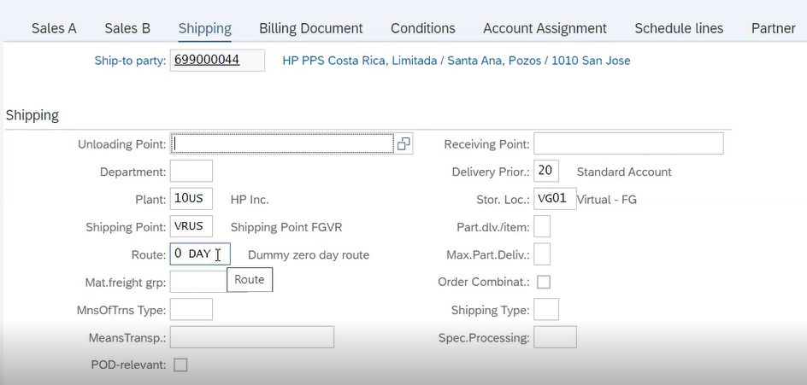

Note: Since there won´t be any physical movement of material to any US location, the **Storage Loc.** will be virtual (VG01) and the **Route** selected must be **0 DAY** (Dummy zero day route).

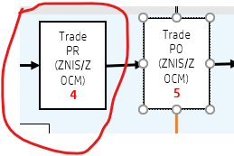

On the **Schedule lines** tab verify the Delivery dates are filled out.

Also verify if a new Requisition number has been created, copy this new PR Number, and keep it on your records.

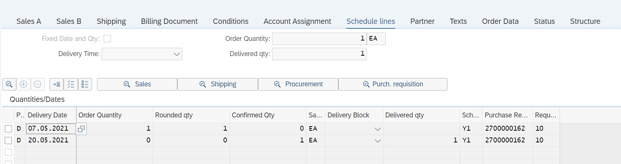

### Click on **Save** on the pop-up message at the bottom of the page.



**End of SO modifications**

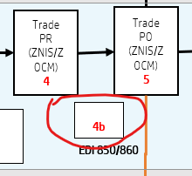

## Trade PR creation

### Go to t-code **ME52N**

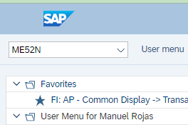

### Go to **Other Purchase Requisition**.

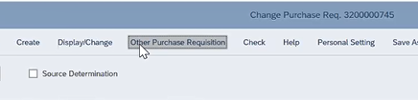

### On the pop-up window, paste the **Purchase Requisition** and press **Enter**.

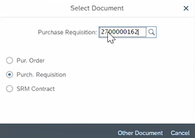

### Go to the **Display/Change** mode.

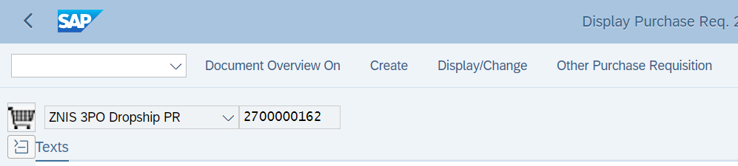

### Go to **Source of Supply** and the **Assign source of Supply**

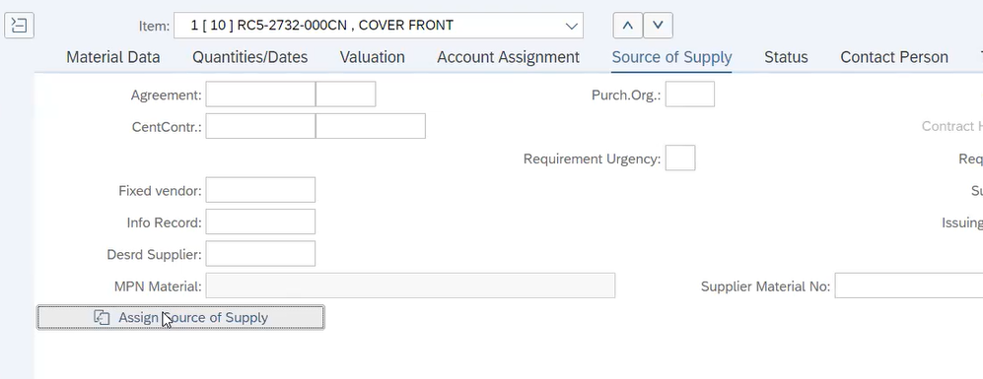

### Click on the Assign Source of Supply to select your supplier.

ZOCM: PIR created (**available** vendors from the dropdown menu of Assign Source of Supply)

ZNIS: Broker Buy (**not possible** for selection of available vendors on the dropdown menu of assign source of supply)

### Manually add the **Desired Supplier** as shown on the next image.

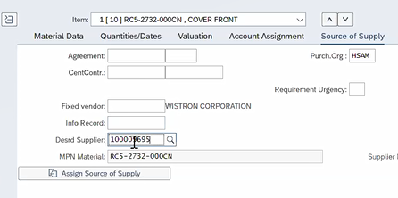

### Go to the **Valuation** and verify that there is a **Valuation Price** on it.

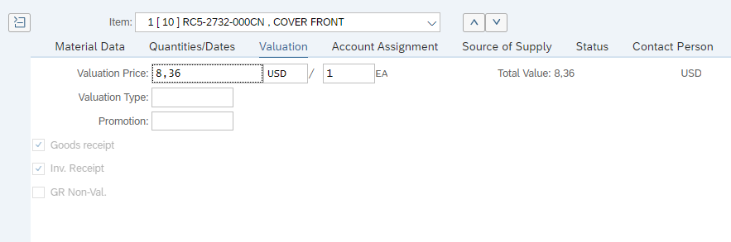

### Select **Check**.

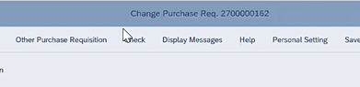

### Click on **Save** on the pop-up message at the bottom of the page, with this step the **ZNIS 3PO Dropship PR** is created.



**End of Trade PR creation**

## Trade PO modification

### On your S/4 CS SC home page, go to **Create Purchase Order (ME21N).**

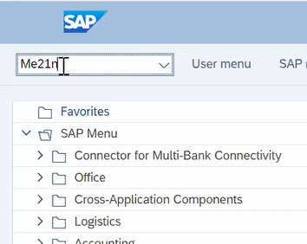

### On the display menu, select **ZNIS 3PO Dropship PO**.

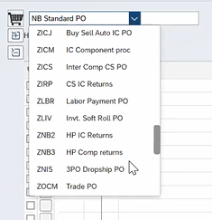

### Scroll to the right and paste the **Purchase Requisition** and press **Enter**.

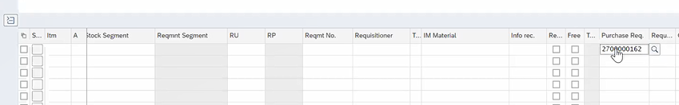

### Manually add the **Net Price** and press **Enter**.

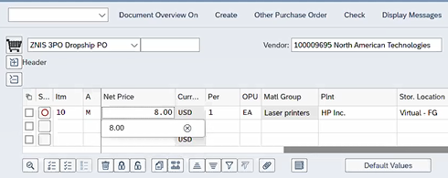

### Select **Check**.

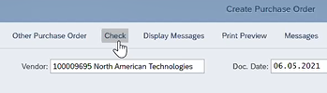

### Go to **Delivery Address** and confirm that the information of the address is correct.

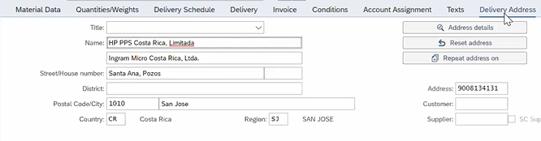

### Select **Save** on the pop-up message at the bottom of the page.



## Inbound Delivery Creation (ML steps)

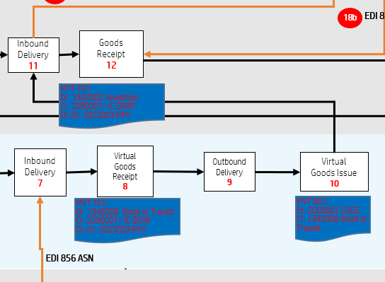

### Enter to S/4 Customer Support Supply Chain production environment using the following link:

[hpiw6qwd00.corp.hpicloud.net:44380/sap/bc/gui/sap/its/webgui#](hpiw6qwd00.corp.hpicloud.net:44380/sap/bc/gui/sap/its/webgui)

### On your S/4 CS SC home page, go to **Create Inbound Delivery (VL31M).**

### **This t-code does not exist on testing environment!!**

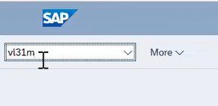

### Insert the **Purchase Order**.

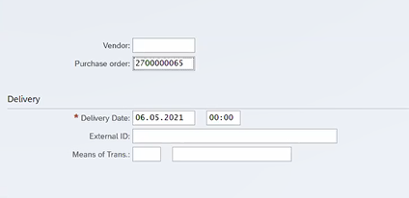

### Click **Continue** on the pop-up window at the bottom of the page.



### Select **Save** on the pop-up message at the bottom of the page.



### On the white box at the top of the window, type **/OME23N** and press **enter**, this will open a new window.

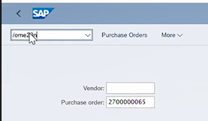

### Validate that the **Inbound Delivery** has been created.

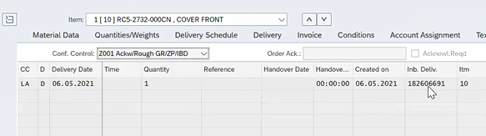

### Double click on the **Inbound delivery Number**, this will open a new window.

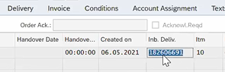

### Go to the change mode by selecting **Display <-> Change**.

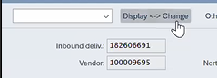

### Scroll to the right and add the **Putaway Quantity**.

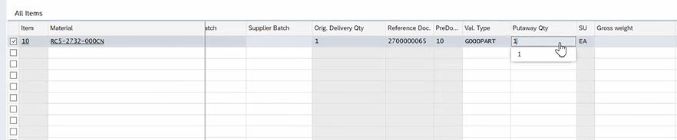

### Go to **Post Goods Receipt** tab and validate the information.

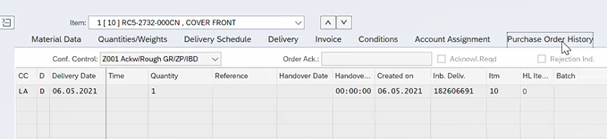

### Refresh the page and go to **Purchase Order History** tab and validate the **Post Goods Receipt**.

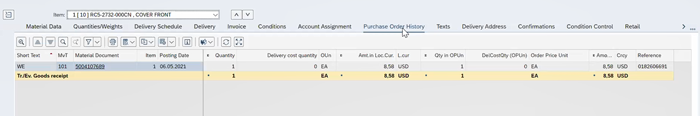

### On your S/4 CS SC home page, go to **Display Sales Document (VA03)**.

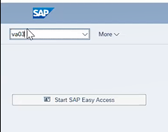

### Insert the **Purchase Order** and press **Enter**.

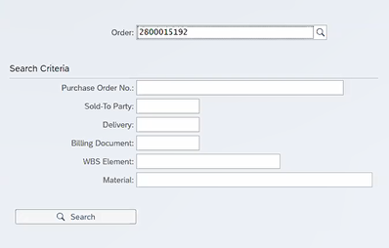

### Select **Change**.



### Double click on the line item.

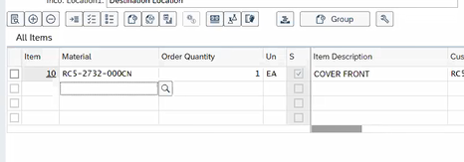

### Validate the information in the **Schedule Lines** tab.

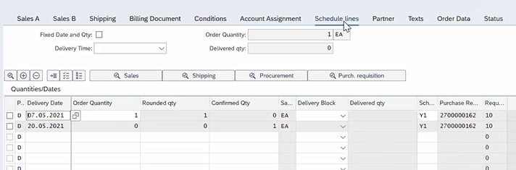

### On your S/4 CS SC home page, go to **Sales Orders, Fast Display (VL10A)**.

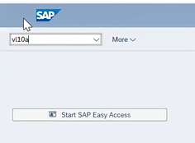

### On the new window, clear the information in the following fields:

### **Delivery Creation Date:**

### **To:**

### **CaclRuleDefitDlvCrDt**:

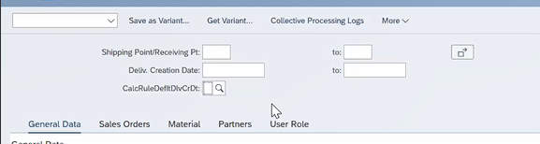

### Go to the **Sales Order** tab and insert the **Sales Document (PO)**.

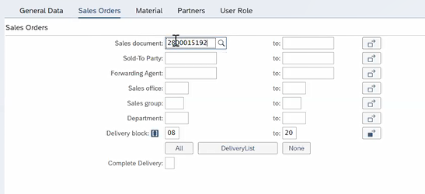

### Click on **Execute** on the pop-up window at the bottom of the page, this step will display a new window.



### Select the **box** on the left-hand side.

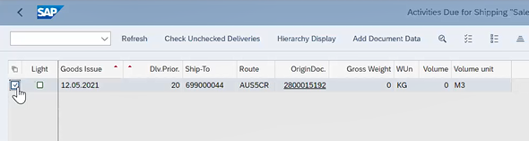

### Click on **Background** on the pop-up window at the bottom of the page.



### On your S/4 CS SC home page, go to **Display Sales Documents (VA03)**.

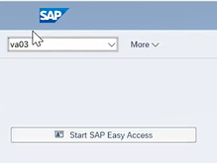

On the new window, add the **PO** press **Enter**.

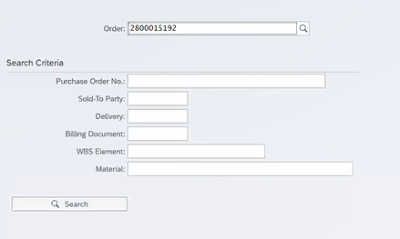

### Go to the **Display Document Flow** tab, this will open a new window where you will find the Purchase Order.

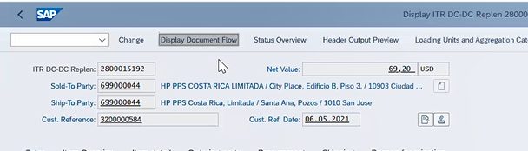

### Select the **Outbound Delivery** and then click on **Display Document**.

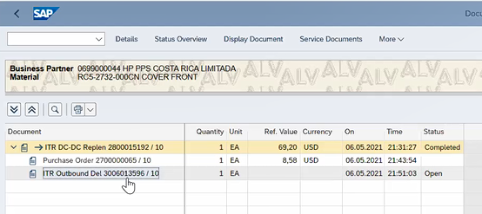

### On the new window, select **Display <-> Change**.

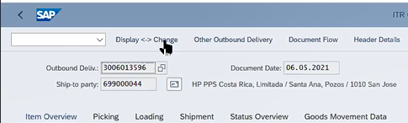

### Go to the **Picking** tab.

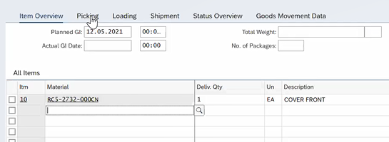

### Enter the **Picked Quantity**.

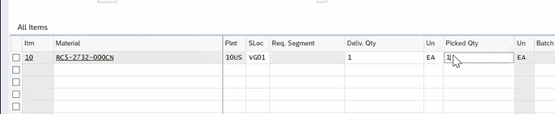

### Go to the Header Details tab.

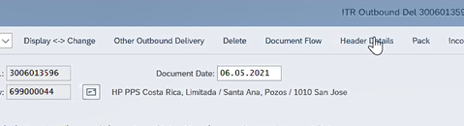

### Go to the **Shipment** tab and add the **BillOfLad** information.

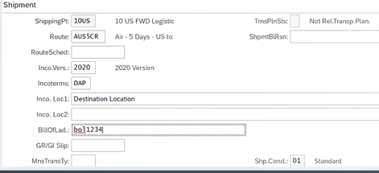

### *Add **bol** at the beginning of the information, this is important for accounting.

### Go to the **Administration** tab and copy the **Delivery Number** from the top title.

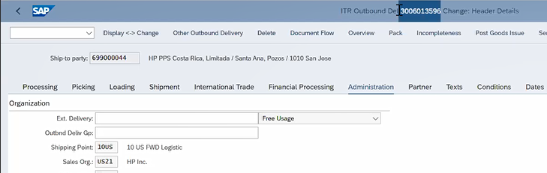

### Paste the **Delivery Number** on **Ext. Delivery**.

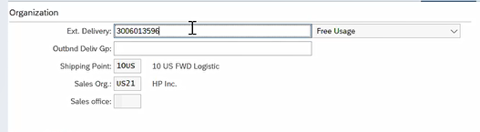

### Go back by selecting the arrow on the top left corner.

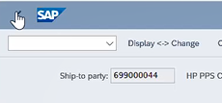

### In the **Picking** tab, select the **Line Item**.

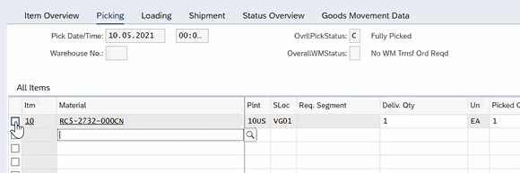

### Go to the **Pack** tab, this step will open a new window.



### In the **Packing Materials** column, press **Space** and it will display a menu, select the **first item** on the list.

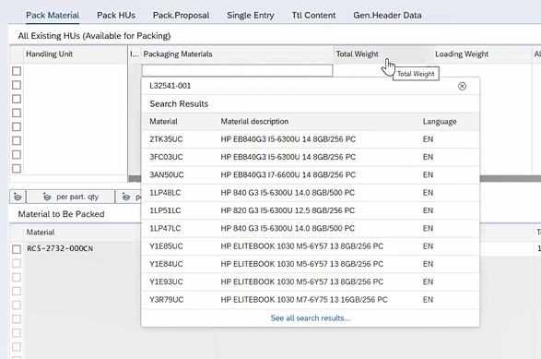

### Click on the **white box on top of the list** on both lists.

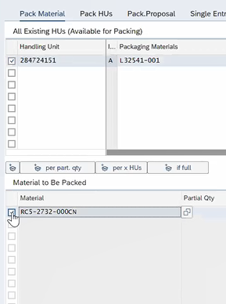

### Click on the **Pack Icon** between the two lists.

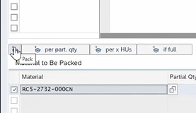

### Double click on the **Handling Unit Number**, this will open a new window.

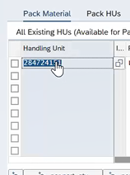

### Go to the **Conts.** tab and select the **Line Item**.

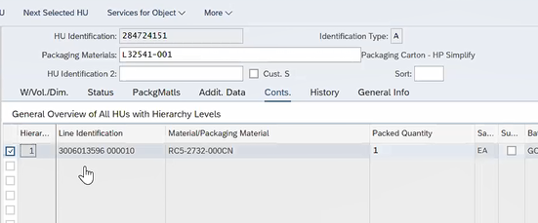

### Open the **Serial Numbers** menu.

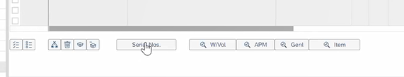

### Select **Create Serial Number Automatically** and click the **Check Mark**.

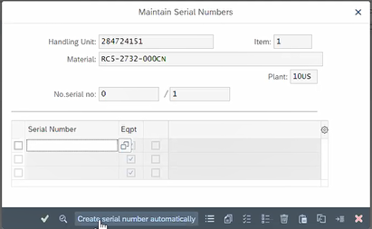

### Click on **Save** on the pop-up window at the bottom of the page, this step will display a new window.



### Select the **Outbound Delivery** and go to **Display Document**.

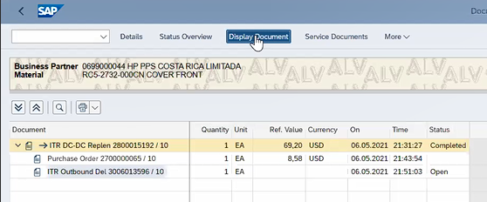

### On the new window, double click on the **Line Item**.

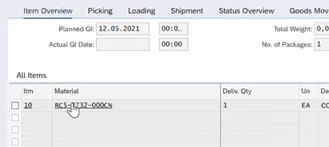

### Select **Display <-> Change**.

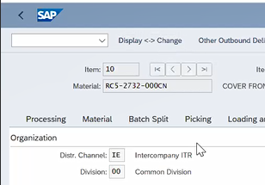

### Go to the **Customs Data** tab and insert the **Country of Origin (COO)** and the **Quantity**.

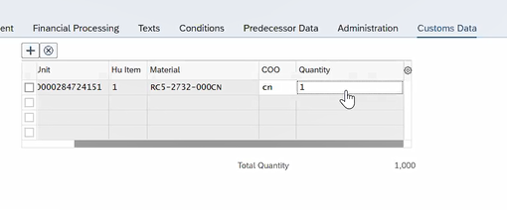

### Go back twice by selecting the arrow on the top left corner.

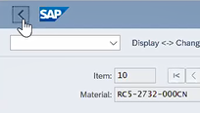

### Select the **Outbound Delivery** and go to **Display Document**.



### Select **Display <-> Change**.

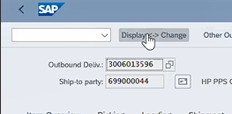

### Go to the **Post Goods Issue** tab and it will open a new window.

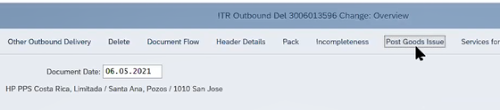

### *The Inbound Delivery and the Virtual PGR have been completed and for the IZSO the Outbound Delivery has been shipped. Now we have to receive the part against the ICPO which is another sales office.

### On your S/4 CS SC home page, go to **Display Sales Documents (VA03)**.



### On the new window, add the **PO** press **Enter**.



### Go to **Display Document Flow** tab.

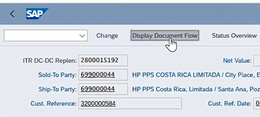

### Validate if you have the **IC Billing** completed.

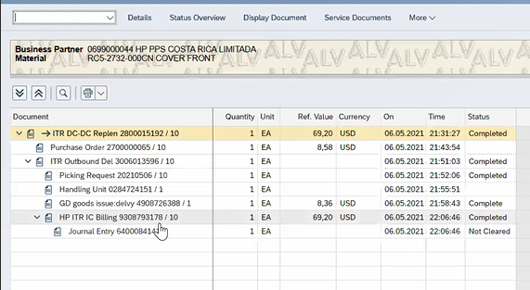

### *If its not done, you will have to wait until it’s completed.

### Select the **IC Billing** and go to the **Display Document** tab.

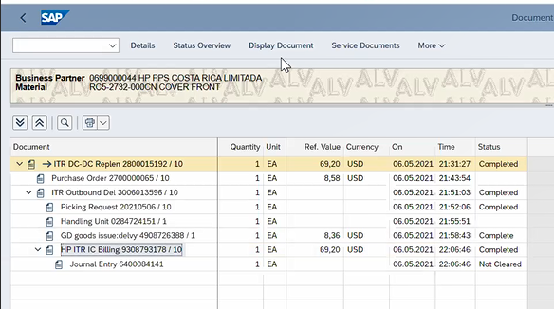

### Click on the **Display Output Request Icon**.

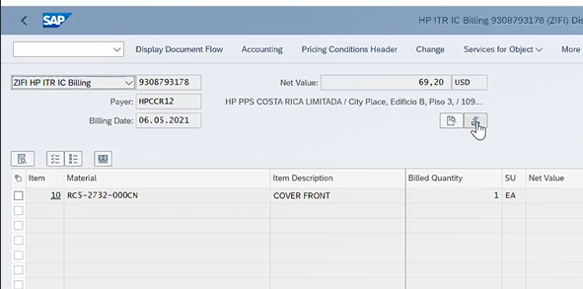

### Validate that the line item **RD04** is green, this is the output that sends the Invoice Receipt Bad Job to create Invoice Receipt in our IC PO.

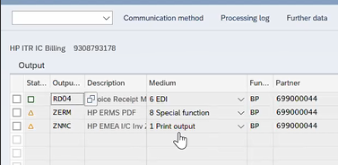

## Post Goods Receipt

This step will be done after Costa Rica receive the parts needed.

### On your S/4 CS SC home page, go to the **PO (ME23N)**.

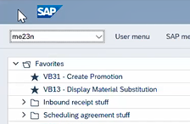

### Go to the **Confirmation** tab and double click on **Inbound Delivery Number**.

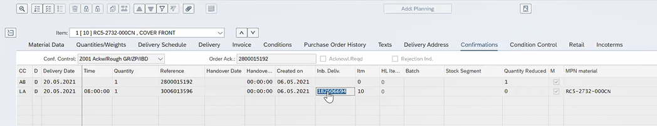

### Select **Display <-> Change**.

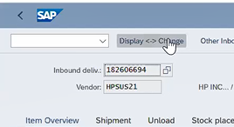

### Select the **Line Item** and God to **Post Goods Receipt**.

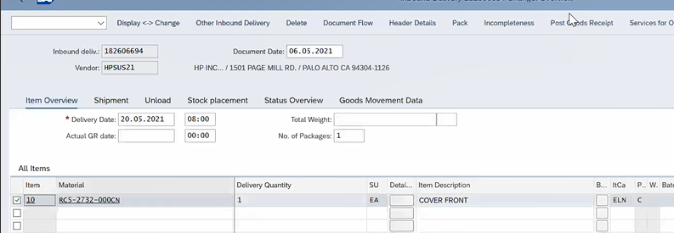

### You will have this pop-up message at the bottom of the page.



### On your S/4 CS SC home page, go to the **PO (ME23N)** to refresh the **PO**.



### Validate the **Purchase Order History** information.

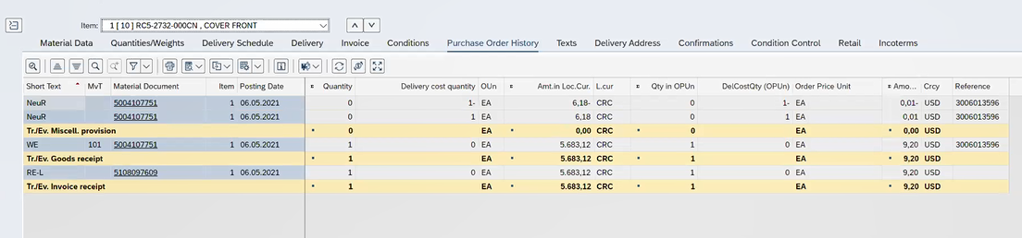

**Important Notes:**

### The PO will go as a Back Order, one 3PO is created you will change the **Item Category** manually.

* There are two Item Categories, first the **ZC3P ITR HP 3PO Replenish** this will create a **ZOCM PR** type, it’s used when we have a contractual agreement and they regularly provide the part.
* Second, the category **ZS3P ITR HP SC 3PO Repin** will trigger a **ZNIS PR PO** type this is the regular broker buy that we don’t maintain the PR recorder.
* We need to wait until the IC Billing is generated in the IZSO and the output maintained will trigger an invoice receipt on the ICPO in Costa Rica, because we should not have the Goods Receipt before Invoice Receipt.
* GTS checks goes after the IC Billing is generated.

**End of Process**

# Process Flow Chart



# Addendum

